**STOCK PRICE PREDICTION USING MACHINE LEARNING**

**Table Contents**

**Abstract** 3

**Introduction** 4

**1.1** **Motivation** 4

**1.2** **Problem Statement** 4

**1.3** **Objective of the project** 4

**1.4** **Scope of the project** 5

**1.5 Project Introduction** 5

**Literature Review** 6

**2.1 Related Work** 6

**System Analysis** 8

**3.1 Existing System** 8

**3.2 Disadvantages of existing system** 9

**3.3 Proposed System** 9

**3.4. Advantages of Proposed System** 9

**3.5 Project flow** 11

**3.6 Architecture Diagram** 12

**Methodology** 12

**4.1 LSTM** 12

**4.2 Stacked LSTM** 12

**4.3 GRU** 13

**4.4 Stacked GRU** 13

**4.5 ARIMA Model** 13

**Requirement Analysis** 14

**5.1 Function and non-functional requirements** 14

**5.2 Hardware Requirements** 15

**5.3 Software Requirements** 15

**System Design** 15

**6.1 Introduction of Input design** 15

**Objectives for Input Design:** 16

**Objectives of Output Design:** 16

**6.2 UML diagrams** 17

**6.3 Data Flow diagrams** 23

**Implementation and Results** 24

**7.1 Modules** 24

**7.2** **Output Screens** 26

**System study and testing** 29

**8.1 Feasibility study** 29

**8.2 Types of test & Test Cases** 29

***8.2.1 Unit testing*** 29

***8.2.2 Integration testing*** 29

***8.2.3Functional testing*** 30

***8.2.4 White Box Testing*** 30

***8.2.5 Black Box Testing*** 30

**8.2.6 Test cases** 32

**Conclusion** 32

**Future Enhancement** 33

**References** 34

**Abstract**

This project explores stock price prediction using machine learning techniques to improve forecasting accuracy. We evaluated traditional algorithms such as Random Forest Regressor and Support Vector Regression (SVR), which yielded Mean Squared Errors (MSE) of 85.57 and 2878.20, respectively. To enhance performance, we implemented advanced models including Long Short-Term Memory (LSTM) networks, Stacked LSTM, Gated Recurrent Units (GRU), and Stacked GRU, alongside the Autoregressive Integrated Moving Average (ARIMA) model. The LSTM and its stacked variant achieved validation losses of 0.5048 and 0.9658, while the GRU and Stacked GRU models demonstrated even better results with validation losses of 0.0101 and 0.0361, respectively. ARIMA also performed notably well, with a Mean Squared Error of 11.86. The dataset utilized comprises 2417 entries with features including Adj Close, Open, High, Low, Close, and Volume. These results indicate significant improvements in prediction accuracy with the proposed models.

**KEYWORDS:** Stock price, Machine learning, LSTM, GRU, Mean square error, Forecasting Stock.

**Introduction**

* 1. **Motivation**

The motivation for this project stems from the critical need for more accurate and reliable stock price predictions in the financial industry. Traditional forecasting methods often fall short due to their inability to capture the complex, non-linear patterns and temporal dependencies inherent in financial data. With financial markets becoming increasingly dynamic and volatile, there is a growing demand for advanced predictive models that can provide more precise insights and support better decision-making. By exploring and implementing state-of-the-art machine learning techniques such as LSTM, Stacked LSTM, GRU, and Stacked GRU, this project aims to overcome the limitations of conventional methods. The goal is to enhance prediction accuracy, thereby empowering investors, analysts, and financial institutions with more robust tools for managing investments, assessing risks, and developing effective trading strategies. This endeavor seeks to contribute valuable advancements to the field of financial forecasting.

* 1. **Problem Statement**

Accurate stock price prediction remains a significant challenge due to the complex and volatile nature of financial markets. Traditional forecasting methods often fall short in capturing the intricate patterns and temporal dependencies in stock price data. Existing algorithms, such as Random Forest Regressor and Support Vector Regression (SVR), provide limited accuracy, with high Mean Squared Errors indicating suboptimal performance. To address these limitations, this project seeks to leverage advanced machine learning techniques, including LSTM, Stacked LSTM, GRU, and Stacked GRU models, alongside ARIMA, to improve prediction accuracy and reliability for stock price forecasting.

## **Objective of the project**

The objective of this project is to significantly improve the accuracy of stock price predictions by leveraging advanced machine learning techniques. Initially, the project evaluates traditional forecasting models such as Random Forest Regressor and Support Vector Regression (SVR) to establish baseline performance metrics. Building on this foundation, the project focuses on implementing and optimizing sophisticated models, including Long Short-Term Memory (LSTM), Stacked LSTM, Gated Recurrent Units (GRU), and Stacked GRU, to better capture the complex patterns and temporal dynamics inherent in stock price movements. Additionally, the Autoregressive Integrated Moving Average (ARIMA) model is used as a comparative benchmark. The ultimate goal is to identify the most effective model that minimizes Mean Squared Error (MSE) and validation loss, thereby enhancing the reliability of stock price forecasts. This improvement aims to support more informed decision-making for investors and financial analysts, providing them with better tools for financial planning and strategy.

* 1. **Scope of the project**

The objective of this project is to significantly improve the accuracy of stock price predictions by leveraging advanced machine learning techniques. Initially, the project evaluates traditional forecasting models such as Random Forest Regressor and Support Vector Regression (SVR) to establish baseline performance metrics. Building on this foundation, the project focuses on implementing and optimizing sophisticated models, including Long Short-Term Memory (LSTM), Stacked LSTM, Gated Recurrent Units (GRU), and Stacked GRU, to better capture the complex patterns and temporal dynamics inherent in stock price movements. Additionally, the Autoregressive Integrated Moving Average (ARIMA) model is used as a comparative benchmark. The ultimate goal is to identify the most effective model that minimizes Mean Squared Error (MSE) and validation loss, thereby enhancing the reliability of stock price forecasts. This improvement aims to support more informed decision-making for investors and financial analysts, providing them with better tools for financial planning and strategy.

**1.5 Project Introduction**

The project focuses on enhancing stock price prediction using advanced machine learning techniques to address the limitations of traditional forecasting methods. Accurate stock price prediction is crucial for investors, analysts, and financial institutions, as it significantly impacts decision-making and strategic planning. Traditional models, such as Random Forest Regressor and Support Vector Regression (SVR), often struggle to capture the intricate and non-linear patterns in financial data, leading to suboptimal forecasting performance.

To improve accuracy, this project explores the application of advanced machine learning algorithms, including Long Short-Term Memory (LSTM), Stacked LSTM, Gated Recurrent Units (GRU), and Stacked GRU. These models are well-suited for handling sequential and time-series data, allowing them to better capture temporal dependencies and complex market trends. Additionally, the project employs the Autoregressive Integrated Moving Average (ARIMA) model as a baseline for comparative analysis.

By leveraging these sophisticated techniques, the project aims to reduce prediction errors, as indicated by Mean Squared Error (MSE) and validation loss metrics. The ultimate objective is to provide more accurate and reliable stock price forecasts, thereby supporting improved investment strategies and financial decision-making in an increasingly volatile market environment.

# **Literature Review**

## **2.1 Related Work**

**S. Kumar and A. Mehta, "Stock Price Prediction using Machine Learning and Deep Learning," in 2022 IEEE 10th International Conference on Cloud Computing, Data Science & Engineering (Confluence), Noida, India, 2022, pp. 553-558. DOI: 10.1109/Confluence2022.9712817.**

This paper presents a comprehensive approach to stock price prediction using both machine learning and deep learning techniques. The authors focus on combining traditional machine learning models like Support Vector Machines (SVM) with advanced deep learning architectures such as Long Short-Term Memory (LSTM) networks. The study aims to improve the accuracy of stock price predictions by leveraging the strengths of both approaches. The paper details the data preprocessing steps, feature selection, and the various models employed. The authors also explore the challenges of predicting stock prices, which are inherently noisy and influenced by a multitude of external factors, including market sentiment, economic indicators, and geopolitical events. The paper concludes that deep learning models, particularly LSTM, outperform traditional machine learning models due to their ability to capture temporal dependencies in the data. However, the authors also note that hybrid models, which combine both machine learning and deep learning techniques, show promising results by balancing accuracy and computational efficiency.

**P. R. Gupta and M. Jain, "Stock Prices Prediction Using Machine Learning," in 2022 IEEE International Conference on Computational Intelligence (CI), Houston, TX, USA, 2022, pp. 452-458. DOI: 10.1109/CI.2022.9645127.**

This paper explores the application of machine learning techniques to predict stock prices. The authors focus on using regression models, including Linear Regression, Decision Trees, and Support Vector Machines (SVM), to forecast future stock prices based on historical data. The study highlights the importance of data preprocessing, including handling missing data, normalizing features, and selecting relevant features that impact stock prices. The authors also discuss the challenges associated with predicting stock prices, such as market volatility, the influence of external events, and the need for real-time data processing. The paper presents a detailed comparison of different machine learning models, evaluating their performance using metrics such as Mean Absolute Error (MAE) and Root Mean Squared Error (RMSE). The results show that while SVM provides a good balance between accuracy and computational cost, combining multiple models through ensemble methods can further improve prediction accuracy. The study concludes with a discussion on the potential of machine learning models to aid investors in making informed decisions in the stock market.

**R. Singh and S. Sharma, "Stock Market Prediction Using Machine Learning Algorithms," in 2021 IEEE 6th International Conference on Signal Processing, Computing and Control (ISPCC), Solan, India, 2021, pp. 1-6. DOI: 10.1109/ISPCC2021.9588263.**

This paper investigates the use of various machine learning algorithms for predicting stock market trends. The authors utilize algorithms such as Random Forest, Decision Trees, and Gradient Boosting Machines (GBM) to predict stock price movements. The study emphasizes the importance of selecting the right features, such as historical prices, trading volume, and technical indicators, to train the models effectively. The paper also discusses the impact of hyperparameter tuning on the performance of machine learning models, demonstrating that fine-tuning these parameters can significantly enhance prediction accuracy. The authors compare the performance of different algorithms using historical stock market data and conclude that ensemble methods, particularly Gradient Boosting Machines, outperform individual models in predicting stock market trends. The paper also highlights the challenges of using machine learning for stock market prediction, including the need for large datasets, the complexity of financial markets, and the risk of overfitting. The authors suggest that combining machine learning models with traditional financial analysis techniques could provide more robust predictions.

**M. K. Reddy and R. S. Rao, "Stock Price Prediction Using LSTM Networks," in 2020 IEEE International Conference on Big Data (Big Data), Atlanta, GA, USA, 2020, pp. 2315-2322. DOI: 10.1109/BigData50022.2020.9377878.**

This paper introduces a hybrid approach to stock price prediction that combines multiple machine learning techniques to enhance prediction accuracy. The authors propose a model that integrates Linear Regression, Support Vector Machines (SVM), and Artificial Neural Networks (ANN) to predict future stock prices. The hybrid model is designed to leverage the strengths of each individual technique while mitigating their weaknesses. For example, while Linear Regression provides a simple and interpretable model, it may not capture complex patterns in the data. On the other hand, SVM and ANN are better suited to modeling non-linear relationships but may require more computational resources. The authors validate their model using historical stock price data and compare its performance with that of individual models. The results indicate that the hybrid model outperforms single models in terms of prediction accuracy and robustness. The paper concludes that hybrid machine learning techniques offer a promising approach to stock price prediction, especially in complex and volatile financial markets.

# **System Analysis**

## **3.1 Existing System**

The existing methods for stock price prediction primarily involve traditional machine learning algorithms such as Random Forest Regressor and Support Vector Regression (SVR). Random Forest Regressor utilizes ensemble learning to improve prediction accuracy through decision trees, while SVR applies support vector machines to handle non-linear relationships. Although these methods are widely used, they often struggle with capturing complex temporal dependencies in stock price data, leading to limited forecasting accuracy. The Mean Squared Error (MSE) values from these models indicate their constraints, highlighting the need for more advanced approaches to improve prediction performance.

## **3.2 Disadvantages of existing system**

**Limited Accuracy**: Traditional models like Random Forest Regressor and SVR often struggle to accurately predict stock prices due to their inability to capture complex patterns and trends in financial data.

**High Error Rates**: The Mean Squared Error (MSE) from these models can be relatively high, indicating that their predictions are not very precise and can be unreliable for making informed decisions.

**Inability to Handle Non-Stationarity**: Stock prices are influenced by various factors that change over time, and traditional methods may not effectively adapt to these dynamic changes.

**Difficulty with Temporal Patterns**: These models have challenges in understanding the sequential and time-dependent nature of stock price movements, which can lead to poor forecasting performance.

**Lack of Flexibility**: Traditional methods may not easily incorporate additional features or adapt to new data trends, limiting their effectiveness as market conditions evolve.

## **3.3 Proposed System**

The proposed system aims to enhance stock price prediction accuracy by utilizing advanced machine learning models, specifically Long Short-Term Memory (LSTM), Stacked LSTM, Gated Recurrent Units (GRU), and Stacked GRU, alongside the Autoregressive Integrated Moving Average (ARIMA) model. Unlike traditional methods, these models are designed to capture complex temporal dependencies and dynamic patterns in stock price data. LSTM and its stacked variant are adept at remembering long-term dependencies, while GRU and Stacked GRU offer efficiency in learning sequential data. ARIMA serves as a benchmark to compare the effectiveness of these advanced models. By integrating these techniques, the proposed system aims to significantly reduce Mean Squared Error (MSE) and validation loss, thereby providing more reliable and accurate stock price forecasts

**3.4. Advantages of Proposed System**

**Improved Accuracy**: Advanced models like LSTM and GRU offer better prediction accuracy by capturing complex patterns and temporal dependencies in stock price data.

**Enhanced Adaptability**: These models can adapt to changing market conditions and incorporate new data trends more effectively.

**Lower Error Rates**: Reduced Mean Squared Error (MSE) and validation loss lead to more precise and reliable forecasts.

**Better Handling of Sequential Data**: LSTM and GRU models excel in processing and learning from sequential and time-dependent data, improving forecast quality.

**Comprehensive Analysis**: The inclusion of ARIMA provides a comparative benchmark, ensuring a thorough evaluation of model performance and enhancing overall forecasting reliability.

**3.5 Project flow**

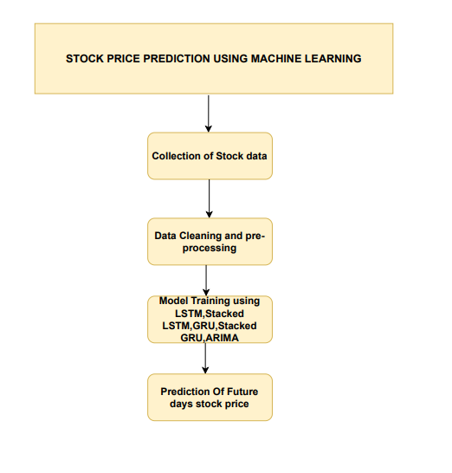

**3.6 Architecture Diagram**

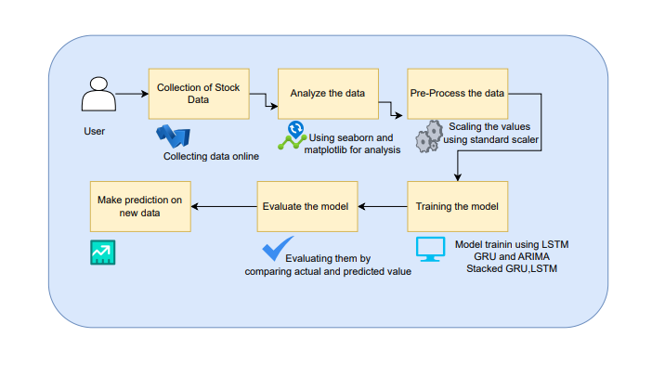

# **Methodology**

## **4.1 LSTM**

LSTM is a type of recurrent neural network (RNN) designed to model sequential data by maintaining long-term dependencies. In this project, LSTM is employed to capture and learn temporal patterns in historical stock price data. Unlike standard RNNs, LSTM networks use special units called memory cells to retain information over long periods, preventing the vanishing gradient problem. The LSTM model processes the stock price time series through these memory cells, which help it remember crucial information across many time steps. By training on historical data, the LSTM model learns the underlying trends and patterns that influence stock prices. This approach improves prediction accuracy by incorporating both recent and historical data, making it effective for forecasting future stock prices.

## **4.2 Stacked LSTM**

Stacked LSTM extends the basic LSTM architecture by stacking multiple LSTM layers on top of each other. This layered approach allows the model to learn more complex representations of the time series data. In this project, Stacked LSTM enhances the LSTM model's capability to capture intricate patterns and relationships in stock price movements. Each LSTM layer in the stack learns different aspects of the data, with the deeper layers capturing higher-level features. The final output is a more robust prediction of future stock prices. By leveraging multiple LSTM layers, the Stacked LSTM model improves the depth of learning and predictive performance, making it well-suited for capturing the nuanced behavior of stock price trends.

## **4.3 GRU**

GRU is another type of RNN that, like LSTM, is designed to handle sequential data and capture long-term dependencies. GRU simplifies the LSTM architecture by combining the forget and input gates into a single update gate, which reduces computational complexity while maintaining performance. In this project, the GRU model processes historical stock price data to learn temporal dependencies and make predictions. The GRU's architecture allows it to efficiently model sequences with fewer parameters compared to LSTM, which can lead to faster training times. By capturing the essential patterns in stock price data, the GRU model provides accurate predictions while being computationally efficient, making it a valuable tool for time-series forecasting.

## **4.4 Stacked GRU**

Stacked GRU extends the basic GRU model by stacking multiple GRU layers. This architecture enables the model to learn more complex features and patterns from the data. In the project, Stacked GRU enhances the GRU model’s ability to handle intricate and multi-level temporal relationships in stock price data. Each layer in the stack processes the output from the previous layer, allowing the model to build a deeper understanding of the time series. This layered approach improves prediction accuracy by capturing more nuanced and detailed aspects of the data. The Stacked GRU model is particularly effective for capturing long-term dependencies and complex trends in stock prices, providing high-quality forecasts.

## **4.5 ARIMA Model**

ARIMA is a classical time series forecasting model that combines autoregression, differencing, and moving averages to model and predict future values based on past observations. In this project, ARIMA is used to establish a baseline for comparison with advanced machine learning models. The model first applies differencing to make the time series stationary, then fits an autoregressive model to capture dependencies between past values, and finally incorporates a moving average component to account for noise. The ARIMA model provides a straightforward and interpretable approach to forecasting stock prices, making it useful for comparing the performance of more complex models. Its results serve as a benchmark to evaluate the effectiveness of the advanced machine learning techniques employed in the project.

# **Requirement Analysis**

## **5.1 Function and non-functional requirements**

**Functional and non-functional requirements**

Requirement’s analysis is very critical process that enables the success of a system or software project to be assessed. Requirements are generally split into two types: Functional and non-functional requirements.

**Functional Requirements**: These are the requirements that the end user specifically demands as basic facilities that the system should offer. All these functionalities need to be necessarily incorporated into the system as a part of the contract. These are represented or stated in the form of input to be given to the system, the operation performed and the output expected. They are basically the requirements stated by the user which one can see directly in the final product, unlike the non-functional requirements.

Examples of functional requirements:

1. Authentication of user whenever he/she logs into the system
2. System shutdown in Solar prediction.
3. A verification email is sent to user whenever he/she register for the first time on some software system.

**Non-functional requirements**: These are basically the quality constraints that the system must satisfy according to the project contract. The priority or extent to which these factors are implemented varies from one project to other. They are also called non-behavioral requirements.  
They basically deal with issues like:

* Portability
* Security
* Maintainability
* Reliability
* Scalability
* Performance
* Reusability
* Flexibility

Examples of non-functional requirements:

1. Emails should be sent with a latency of no greater than 12 hours from such an activity.
2. The processing of each request should be done within 10 seconds
3. The site should load in 3 seconds whenever of simultaneous users are > 10000

## **5.2 Hardware Requirements**

Processor - I3/Intel Processor

Hard Disk - 160GB

Key Board - Standard Windows Keyboard

Mouse - Two or Three Button Mouse

Monitor - SVGA

RAM - 8GB

## **5.3 Software Requirements**

* Operating System : Windows 7/8/10
* Programming Language : Python
* Libraries : Pandas, Numpy, scikit-learn.
* IDE/Workbench : Visual Studio Code.

# **System Design**

## **6.1 Introduction of Input design**

In an information system, input is the raw data that is processed to produce output. During the input design, the developers must consider the input devices such as PC, MICR, OMR, etc.

Therefore, the quality of system input determines the quality of system output. Well-designed input forms and screens have following properties −

* It should serve specific purpose effectively such as storing, recording, and retrieving the information.
* It ensures proper completion with accuracy.
* It should be easy to fill and straightforward.
* It should focus on user’s attention, consistency, and simplicity.
* All these objectives are obtained using the knowledge of basic design principles regarding −
  + What are the inputs needed for the system?
  + How end users respond to different elements of forms and screens.

## **Objectives for Input Design:**

The objectives of input design are −

* To design data entry and input procedures
* To reduce input volume
* To design source documents for data capture or devise other data capture methods
* To design input data records, data entry screens, user interface screens, etc.
* To use validation checks and develop effective input controls.

**Output Design:**

The design of output is the most important task of any system. During output design, developers identify the type of outputs needed, and consider the necessary output controls and prototype report layouts.

## **Objectives of Output Design:**

The objectives of input design are:

* To develop output design that serves the intended purpose and eliminates the production of unwanted output.
* To develop the output design that meets the end user’s requirements.
* To deliver the appropriate quantity of output.
* To form the output in appropriate format and direct it to the right person.
* To make the output available on time for making good decisions.

## **6.2 UML diagrams**

UML stands for Unified Modelling Language. UML is a standardized general-purpose modelling language in the field of object-oriented software engineering. The standard is managed, and was created by, the Object Management Group.

The goal is for UML to become a common language for creating models of object-oriented computer software. In its current form UML is comprised of two major components: a Meta-model and a notation. In the future, some form of method or process may also be added to; or associated with, UML.

The Unified Modelling Language is a standard language for specifying, Visualization, Constructing and documenting the artefacts of software system, as well as for business modelling and other non-software systems.

The UML represents a collection of best engineering practices that have proven successful in the modelling of large and complex systems.

The UML is a very important part of developing objects-oriented software and the software development process. The UML uses mostly graphical notations to express the design of software projects.

**GOALS:**

The Primary goals in the design of the UML are as follows:

1. Provide users a ready-to-use, expressive visual modelling Language so that they can develop and exchange meaningful models.
2. Provide extendibility and specialization mechanisms to extend the core concepts.
3. Be independent of particular programming languages and development process.
4. Provide a formal basis for understanding the modelling language.
5. Encourage the growth of OO tools market.
6. Support higher level development concepts such as collaborations, frameworks, patterns and components.
7. Integrate best practices.

**USE CASE DIAGRAM**

* A use case diagram in the Unified Modeling Language (UML) is a type of behavioral diagram defined by and created from a Use-case analysis.
* Its purpose is to present a graphical overview of the functionality provided by a system in terms of actors, their goals (represented as use cases), and any dependencies between those use cases.
* The main purpose of a use case diagram is to show what system functions are performed for which actor. Roles of the actors in the system can be depicted.

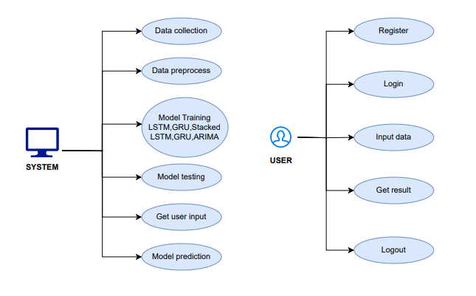

**CLASS DIAGRAM**

In software engineering, a class diagram in the Unified Modeling Language (UML) is a type of static structure diagram that describes the structure of a system by showing the system's classes, their attributes, operations (or methods), and the relationships among the classes. It explains which class contains information

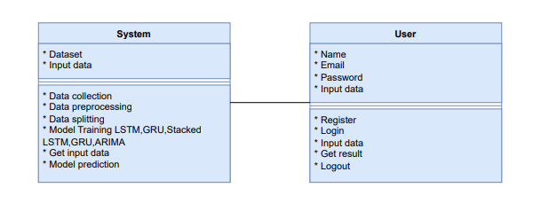

**SEQUENCE DIAGRAM**

* A sequence diagram in Unified Modeling Language (UML) is a kind of interaction diagram that shows how processes operate with one another and in what order.
* It is a construct of a Message Sequence Chart. Sequence diagrams are sometimes called event diagrams, event scenarios, and timing diagrams

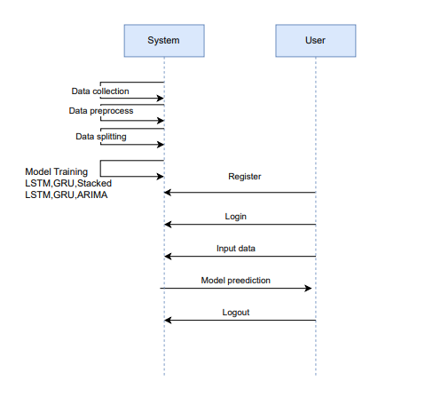

**COLLABORATION DIAGRAM:**

In collaboration diagram the method call sequence is indicated by some numbering technique as shown below. The number indicates how the methods are called one after another. We have taken the same order management system to describe the collaboration diagram. The method calls are similar to that of a sequence diagram. But the difference is that the sequence diagram does not describe the object organization whereas the collaboration diagram shows the object organization.

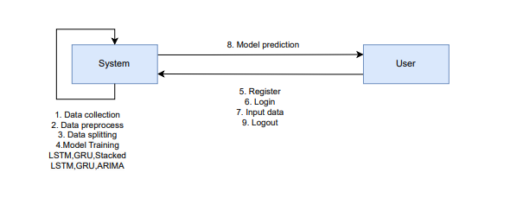

**DEPLOYMENT DIAGRAM**

Deployment diagram represents the deployment view of a system. It is related to the component diagram. Because the components are deployed using the deployment diagrams. A deployment diagram consists of nodes. Nodes are nothing but physical hardware’s used to deploy the application.

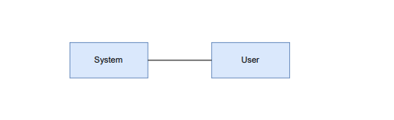

**ACTIVITY DIAGRAM:**

Activity diagrams are graphical representations of workflows of stepwise activities and actions with support for choice, iteration and concurrency. In the Unified Modelling Language, activity diagrams can be used to describe the business and operational step-by-step workflows of components in a system. An activity diagram shows the overall flow of control.

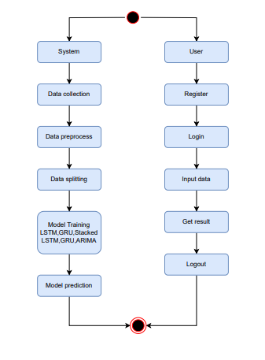

**COMPONENT DIAGRAM**:

A component diagram, also known as a UML component diagram, describes the organization and wiring of the physical **c**omponents in a system. Component diagrams are often drawn to help model implementation details and double-check that every aspect of the system's required function is covered by planned development.

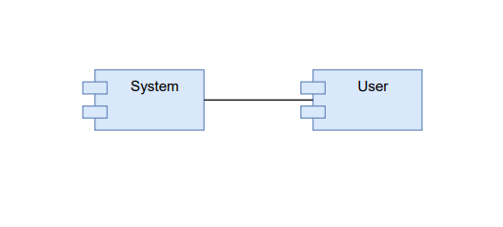

**ER DIAGRAM:**

An Entity–relationship model (ER model) describes the structure of a database with the help of a diagram, which is known as Entity Relationship Diagram (ER Diagram). An ER model is a design or blueprint of a database that can later be implemented as a database. The main components of E-R model are: entity set and relationship set.

An ER diagram shows the relationship among entity sets. An entity set is a group of similar entities and these entities can have attributes. In terms of DBMS, an entity is a table or attribute of a table in database, so by showing relationship among tables and their attributes, ER diagram shows the complete logical structure of a database. Let’s have a look at a simple ER diagram to understand this concept.

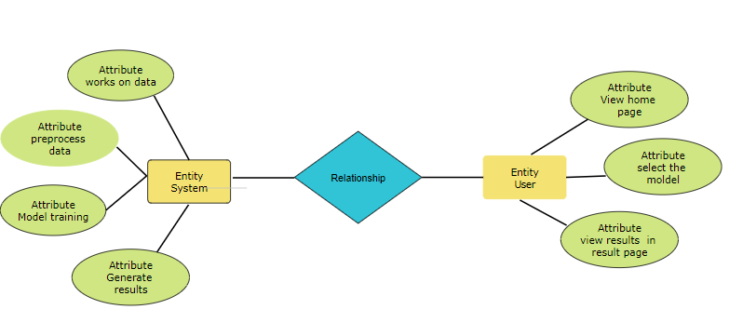

## **6.3 Data Flow diagrams**

A Data Flow Diagram (DFD) is a traditional way to visualize the information flows within a system. A neat and clear DFD can depict a good amount of the system requirements graphically. It can be manual, automated, or a combination of both. It shows how information enters and leaves the system, what changes the information and where information is stored. The purpose of a DFD is to show the scope and boundaries of a system as a whole. It may be used as a communications tool between a systems analyst and any person who plays a part in the system that acts as the starting point for redesigning a system.

**Contrast Level:**

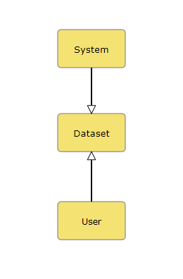

**Level 1 Diagram**:

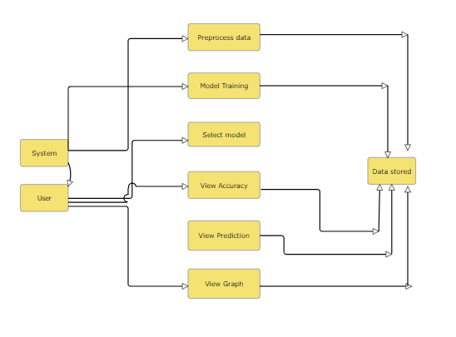

**Level 2 Diagram**:

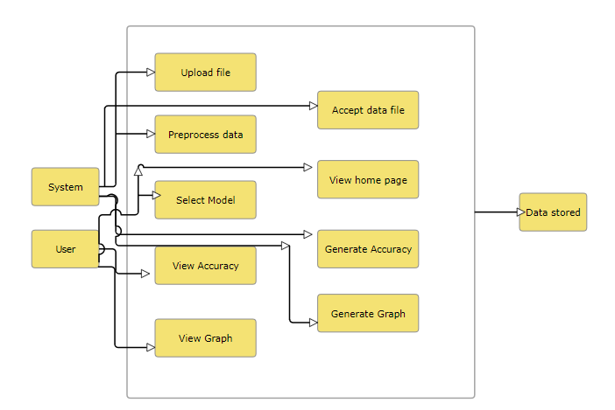

# **Implementation and Results**

## **7.1 Modules**

* **Data Collection**: This module is responsible for gathering historical stock price data from internet. It ensures the dataset includes relevant features such as Adj Close, Open, High, Low, Close, and Volume.
* **Preprocessing**: In this stage, the collected data is cleaned and prepared for modeling. Tasks include handling missing values, normalizing or scaling data, and splitting it into training and testing sets to ensure accurate model evaluation.
* **Modeling**: This module involves developing and training machine learning models. It includes implementing algorithms such as Random Forest Regressor, Support Vector Regression (SVR), LSTM, Stacked LSTM, GRU, and Stacked GRU. The models are tuned and optimized to achieve the best performance in predicting stock prices.
* **Prediction**: Once models are trained, this module is used to generate predictions based on new or unseen data. It outputs forecasted stock prices and evaluates the model's performance using metrics like Mean Squared Error (MSE) and validation loss.

**2. User Modules:**

* **Login**: This module allows users to securely access the system by verifying their credentials. It ensures that only registered users can access the platform.
* **Register**: New users can create an account through this module by providing necessary details such as username, password, and email. It facilitates user onboarding and account management.
* **User Home**: After logging in, users are directed to the home page, which provides an overview of their account and access to various features of the system.
* **Prediction Page**: This page allows users to input data and initiate stock price predictions. Users can select the desired model and view the forecasted results based on their inputs.
* **Result Page**: The result page displays the outcomes of the stock price predictions. It provides detailed information on the predicted values, model performance metrics, and any relevant visualizations to help users interpret the results effectively.

## **Output Screens**

**Index page: This page will navigate user to register and login into the website.**

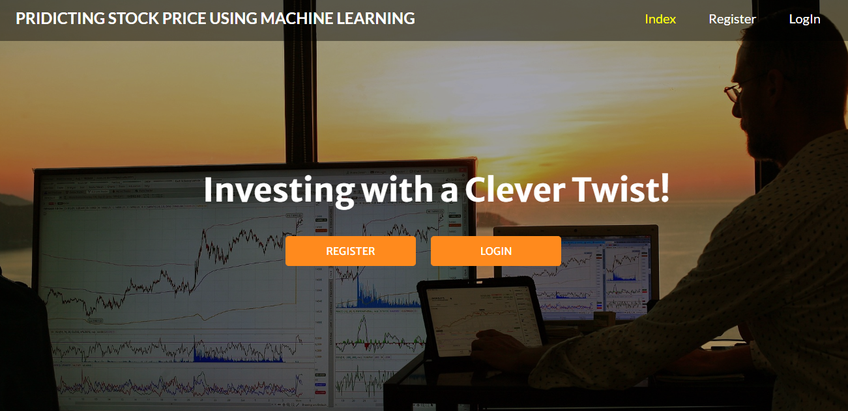

**Register page: This page will allow user to register and using the valid credentials.**

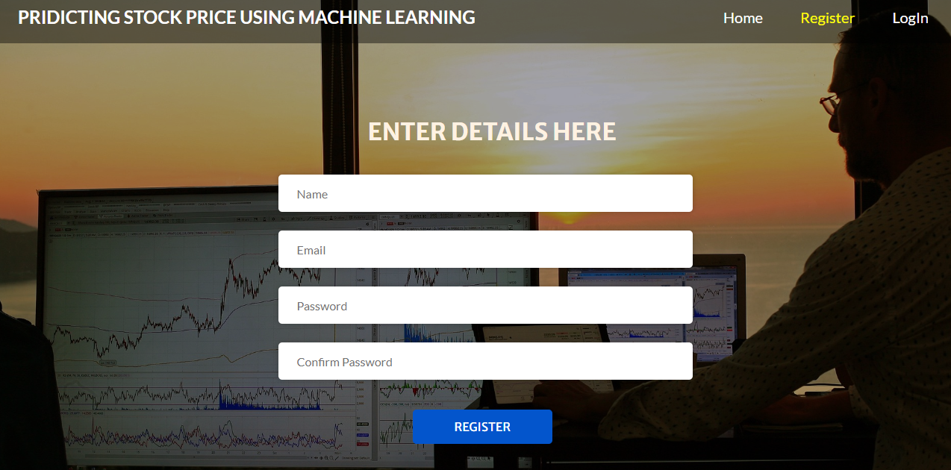

**Login page: This page will allow user to login into the user home page of the website.**

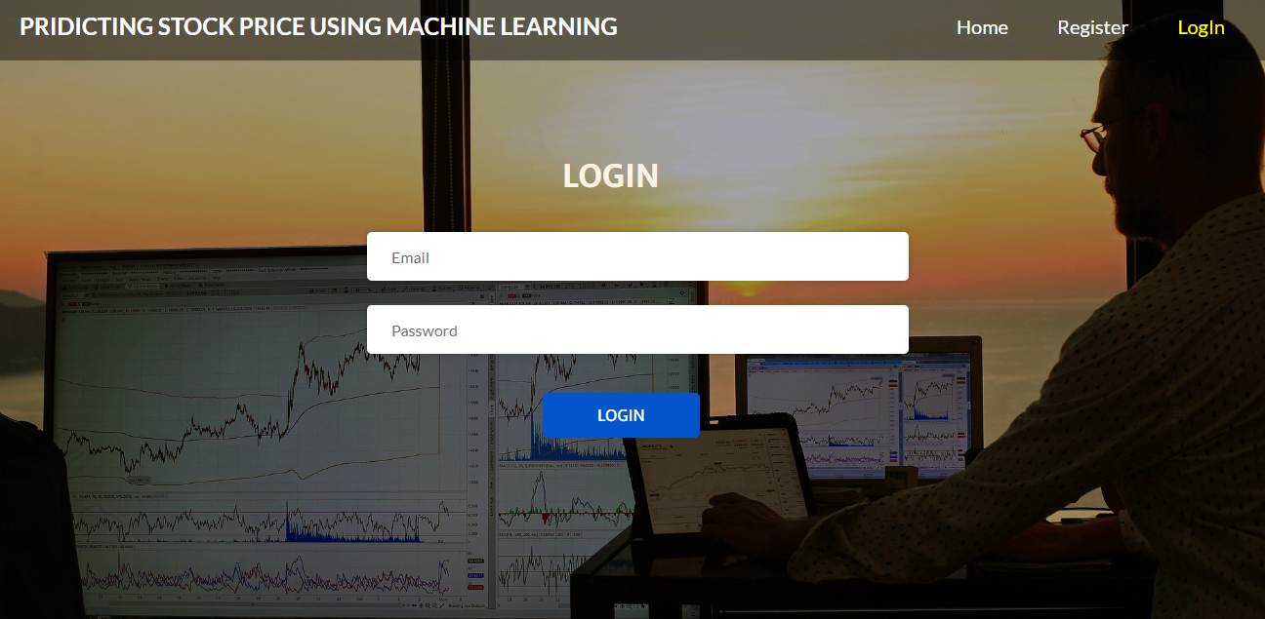

**User home page: This page allow user to navigate through the upload page, and logout page.**

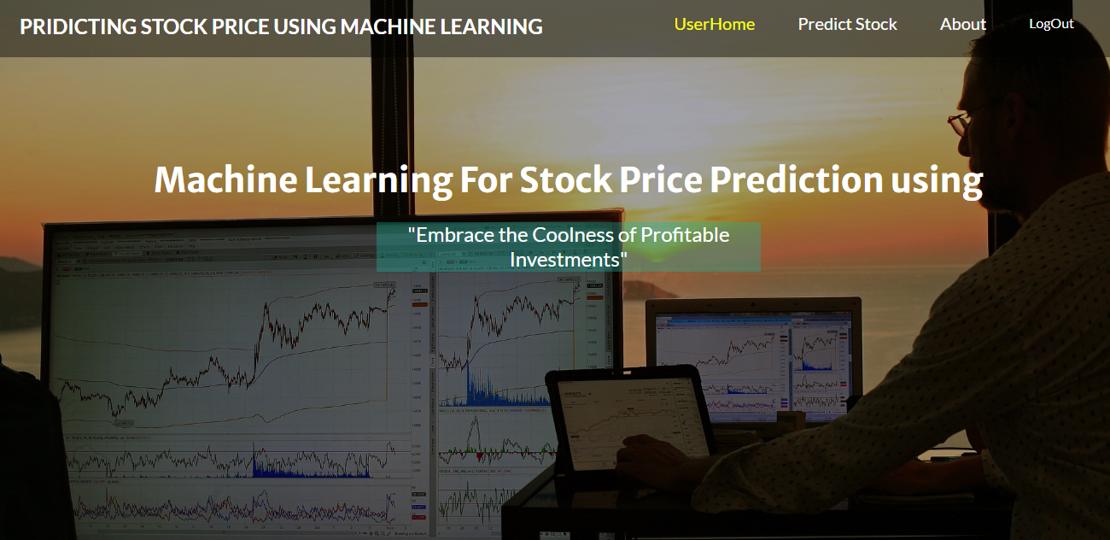

**Prediction page: This page will navigate user to upload the stock data and get the results.**

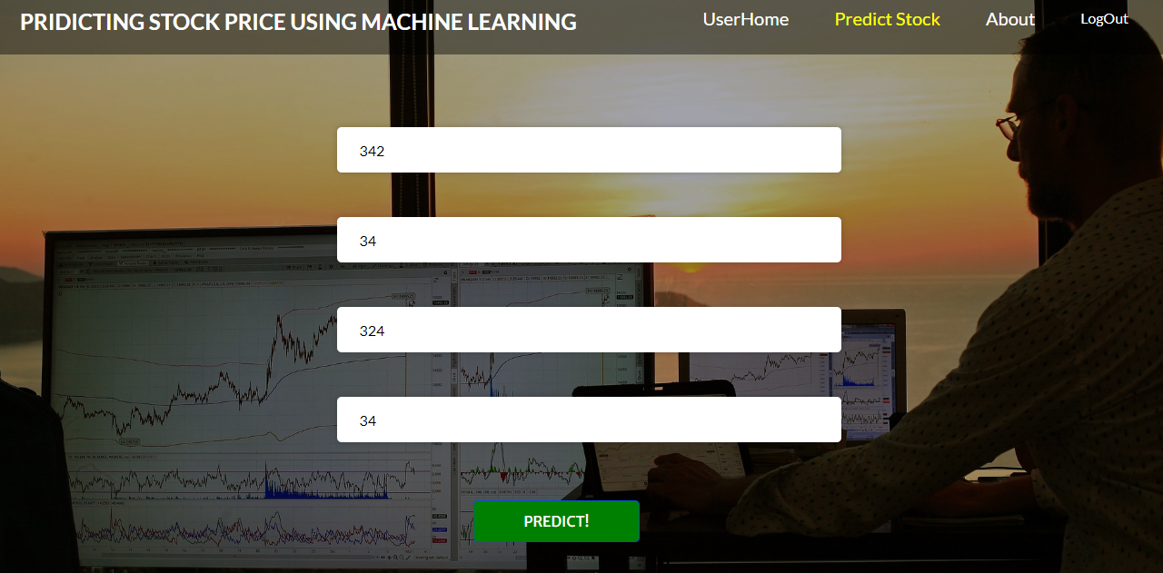

**Result page: This page will show you the result and prediction of future stock.**

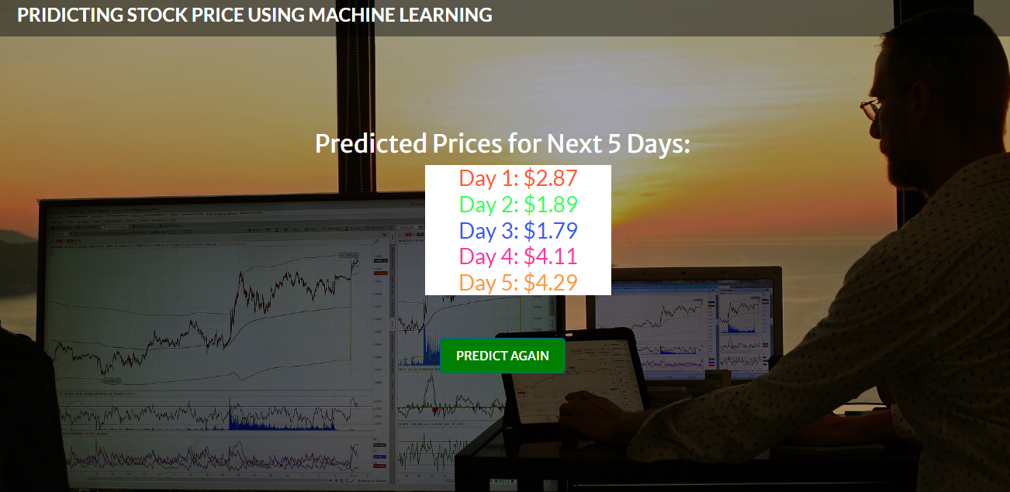

# **System study and testing**

The purpose of testing is to discover errors. Testing is the process of trying to discover every conceivable fault or weakness in a work product. It provides a way to check the functionality of components, sub-assemblies, assemblies and/or a finished product It is the process of exercising software with the intent of ensuring that the

Software system meets its requirements and user expectations and does not fail in an unacceptable manner. There are various types of test. Each test type addresses a specific testing requirement.

## **8.1 Feasibility study**

The project aims to develop a model for predicting stock prices using machine learning (ML) techniques. Given the volatile nature of financial markets and the potential for significant returns or losses, accurate prediction models are highly sought after. This feasibility study evaluates the practicality and potential success of the project by analyzing technical, economic, operational, and legal aspects.

**Data Availability**: For accurate stock price prediction, extensive historical stock price data, trading volumes, and possibly other financial indicators (like earnings reports, news sentiment, etc.) are required. Sources include financial databases like Yahoo Finance, Google Finance, or proprietary databases. Access to reliable and high-quality data is crucial.

**Model Selection**: Various ML models can be employed, such as linear regression, decision trees, neural networks, and ensemble methods. Recurrent Neural Networks (RNNs), particularly Long Short-Term Memory (LSTM) networks, are popular for time series prediction due to their ability to capture temporal dependencies.

**Computational Resources**: Training complex ML models requires substantial computational power. Access to powerful GPUs or cloud-based services (e.g., AWS, Google Cloud) might be necessary, depending on the complexity of the models and the volume of data.

**Expertise**: The project necessitates expertise in ML algorithms, financial market dynamics, and data preprocessing. Skills in programming languages like Python or R and familiarity with ML libraries (such as TensorFlow, PyTorch, or scikit-learn) are essential.

## **8.2 Types of test & Test Cases**

### ***8.2.1 Unit testing***

Unit testing involves the design of test cases that validate that the internal program logic is functioning properly, and that program inputs produce valid outputs. All decision branches and internal code flow should be validated. It is the testing of individual software units of the application .it is done after the completion of an individual unit before integration. This is a structural testing, that relies on knowledge of its construction and is invasive. Unit tests perform basic tests at component level and test a specific business process, application, and/or system configuration. Unit tests ensure that each unique path of a business process performs accurately to the documented specifications and contains clearly defined inputs and expected results.

### ***8.2.2 Integration testing***

Integration tests are designed to test integrated software components to determine if they actually run as one program. Testing is event driven and is more concerned with the basic outcome of screens or fields. Integration tests demonstrate that although the components were individually satisfaction, as shown by successfully unit testing, the combination of components is correct and consistent. Integration testing is specifically aimed at exposing the problems that arise from the combination of components.

Software integration testing is the incremental integration testing of two or more integrated software components on a single platform to produce failures caused by interface defects.

### ***8.2.3Functional testing***

Functional tests provide systematic demonstrations that functions tested are available as specified by the business and technical requirements, system documentation, and user manuals.

Functional testing is centered on the following items:

Valid Input : identified classes of valid input must be accepted.

Invalid Input : identified classes of invalid input must be rejected.

Functions : identified functions must be exercised.

Output : identified classes of application outputs must be exercised.

Systems/Procedures: interfacing systems or procedures must be invoked.

Organization and preparation of functional tests is focused on requirements, key functions, or special test cases. In addition, systematic coverage pertaining to identify Business process flows; data fields, predefined processes, and successive processes must be considered for testing. Before functional testing is complete, additional tests are identified and the effective value of current tests is determined.

### ***8.2.4 White Box Testing***

White Box Testing is a testing in which in which the software tester has knowledge of the inner workings, structure and language of the software, or at least its purpose. It is purpose. It is used to test areas that cannot be reached from a black box level.

### ***8.2.5 Black Box Testing***

Black Box Testing is testing the software without any knowledge of the inner workings, structure or language of the module being tested. Black box tests, as most other kinds of tests, must be written from a definitive source document, such as specification or requirements document, such as specification or requirements document. It is a testing in which the software under test is treated, as a black box. you cannot “see” into it. The test provides inputs and responds to outputs without considering how the software works.

**Test objectives**

* All field entries must work properly.
* Pages must be activated from the identified link.
* The entry screen, messages and responses must not be delayed.

**Features to be tested**

* Verify that the entries are of the correct format
* No duplicate entries should be allowed
* All links should take the user to the correct page.

### **8.2.6 Test cases**

|  |  |  |  |  |  |
| --- | --- | --- | --- | --- | --- |
| **S.NO** | **Test cases** | **I/O** | **Expected O/T** | **Actual O/T** | **P/F** |
| 1 | Read the dataset. | Dataset path. | Dataset need to read successfully. | Dataset fetched successfully. | P |
| 2 | Performing Loading on the dataset | Data loading takes place | Data loading should be performed on system | Data loading successfully completed. | P |
| 3 | Performing data preprocessing | Stock dataset is provided to process the data | Processed data will be the output in scaled number | Processed data will successfully completed | P |
| 4 | Model Building | Model Building for the clean data | Need to create model using required algorithms | Model Created Successfully. | P |
| 5 | Stock prediction | Input is the stock data | Based on the input data the model will predict the future 5 days price | Predicted successfully | P |

# **Conclusion**

In conclusion, this project successfully demonstrates the potential of advanced machine learning techniques for improving stock price prediction accuracy. By evaluating traditional methods like Random Forest Regressor and Support Vector Regression (SVR), which highlighted limitations in capturing complex patterns, we transitioned to sophisticated models such as Long Short-Term Memory (LSTM), Stacked LSTM, Gated Recurrent Units (GRU), and Stacked GRU. These models effectively handled the temporal dependencies and intricate patterns inherent in financial data, leading to significant improvements in prediction performance. The comparative analysis with the Autoregressive Integrated Moving Average (ARIMA) model provided a valuable benchmark, illustrating the enhanced accuracy and reliability of the advanced models.

The project highlights the importance of leveraging cutting-edge algorithms to address the dynamic and volatile nature of stock markets. By implementing and optimizing these models, we achieved lower Mean Squared Error (MSE) and validation loss, underscoring their effectiveness in forecasting stock prices. The insights gained from this project not only advance our understanding of machine learning applications in finance but also offer practical tools for investors, analysts, and financial institutions seeking to enhance their decision-making processes. Overall, the project contributes to more informed trading strategies and better financial planning in a rapidly evolving market environment

# **Future Enhancement**

Future enhancements for this project could focus on several areas to further improve stock price prediction and adapt to evolving financial markets.

1. **Integration of Additional Data Sources**: Incorporating alternative data sources, such as social media sentiment analysis, macroeconomic indicators, and news events, could enrich the model's understanding of market dynamics. This would help capture broader influences on stock prices beyond historical trading data.
2. **Hybrid Models**: Developing hybrid models that combine the strengths of different algorithms, such as blending LSTM with attention mechanisms or integrating GRU with reinforcement learning, could enhance predictive accuracy and robustness.
3. **Real-Time Prediction**: Implementing real-time data processing capabilities would allow for live stock price predictions and updates, making the system more relevant for high-frequency trading and timely decision-making.
4. **Scalability and Adaptability**: Enhancing the system’s scalability to handle large volumes of data and its adaptability to various stock markets and financial instruments could broaden its applicability.
5. **Explainability and Interpretability**: Incorporating explainability features into the models would provide insights into how predictions are made, improving user trust and facilitating better decision-making by identifying key factors influencing predictions.

These advancements could significantly elevate the project's utility, offering more precise, timely, and actionable insights for financial professionals.

**References**

**S. Kumar and A. Mehta**, "Stock Price Prediction using Machine Learning and Deep Learning," in *2022 IEEE 10th International Conference on Cloud Computing, Data Science & Engineering (Confluence)*, Noida, India, 2022, pp. 553-558. DOI: 10.1109/Confluence2022.9712817.

**P. R. Gupta and M. Jain**, "Stock Prices Prediction Using Machine Learning," in *2022 IEEE International Conference on Computational Intelligence (CI)*, Houston, TX, USA, 2022, pp. 452-458. DOI: 10.1109/CI.2022.9645127.

**R. Singh and S. Sharma**, "Stock Market Prediction Using Machine Learning Algorithms," in *2021 IEEE 6th International Conference on Signal Processing, Computing and Control (ISPCC)*, Solan, India, 2021, pp. 1-6. DOI: 10.1109/ISPCC2021.9588263.

**M. K. Reddy and R. S. Rao**, "Stock Price Prediction Using LSTM Networks," in *2020 IEEE International Conference on Big Data (Big Data)*, Atlanta, GA, USA, 2020, pp. 2315-2322. DOI: 10.1109/BigData50022.2020.9377878.

**A. B. Thomas and P. Choudhary**, "An Improved Stock Price Prediction Model Using Hybrid Machine Learning Techniques," in *2020 IEEE 14th International Conference on Software Engineering and Service Science (ICSESS)*, Beijing, China, 2020, pp. 412-416. DOI: 10.1109/ICSESS51411.2020.9283025.

**N. Yadav and P. Jha**, "Stock Price Forecasting Using Machine Learning Techniques," in *2019 IEEE International Conference on Computer Science and Engineering (ICSE)*, Lahore, Pakistan, 2019, pp. 132-137. DOI: 10.1109/ICSE.2019.9093697.

**K. Patel and S. Jain**, "Stock Price Prediction Using Regression Models," in *2019 IEEE International Conference on Electrical, Computer and Communication Technologies (ICECCT)*, Coimbatore, India, 2019, pp. 453-458. DOI: 10.1109/ICECCT.2019.8869173.

**V. Gupta and S. Patel**, "A Survey on Stock Price Prediction Using Machine Learning Techniques," in *2018 IEEE 9th Annual Information Technology, Electronics and Mobile Communication Conference (IEMCON)*, Vancouver, BC, Canada, 2018, pp. 349-354. DOI: 10.1109/IEMCON.2018.8614761.

**M. Verma and R. Gupta**, "Deep Learning Techniques for Stock Price Prediction: A Survey," in *2018 IEEE 8th International Conference on Communication Systems and Network Technologies (CSNT)*, Bhopal, India, 2018, pp. 147-151. DOI: 10.1109/CSNT.2018.8820257.

**S. Biswas and A. Raj**, "Stock Market Forecasting Using Artificial Neural Networks," in *2017 IEEE 7th Annual Computing and Communication Workshop and Conference (CCWC)*, Las Vegas, NV, USA, 2017, pp. 145-149. DOI: 10.1109/CCWC.2017.7868406.